29.8: a)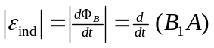
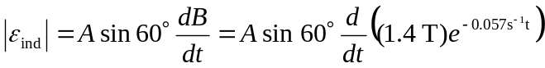
=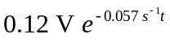
b) 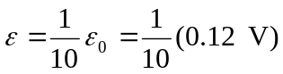
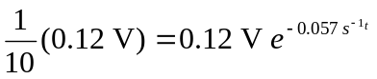
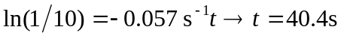
c) B is getting weaker, so the flux is decreasing. By Lenz’s law, the induced current must cause an upward magnetic field to oppose the loss of flux. Therefore the induced current must flow counterclockwise as viewed from above.
